**Assignment 17.1**

1. Write a program to read a text file and print the number of rows of data in the document.

Sol: Hadoop fs –put ‘/home/acadgild/Spark-sample.txt’ /user/acadgild’

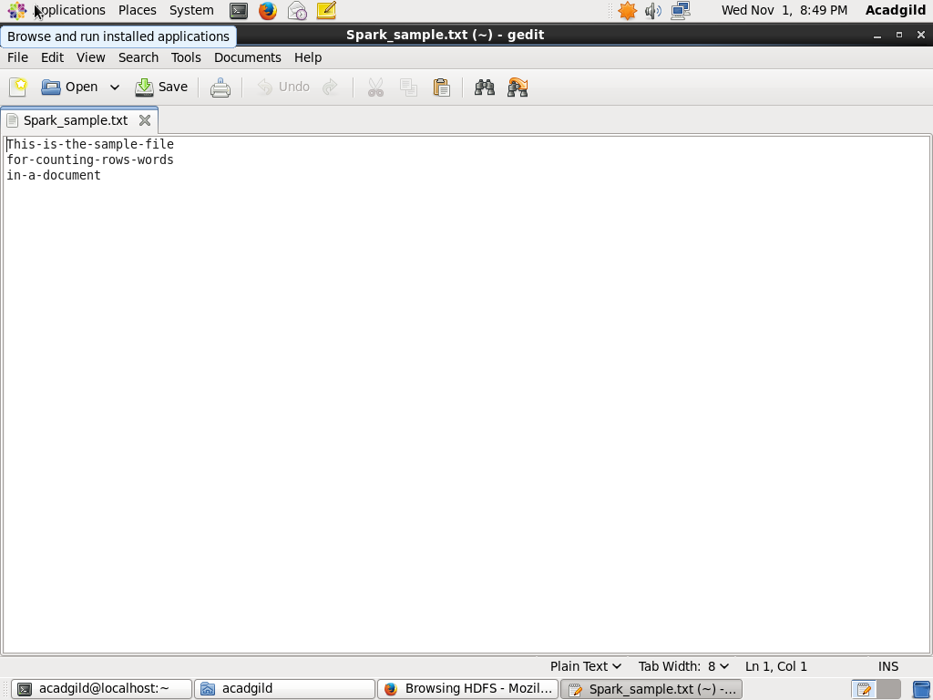

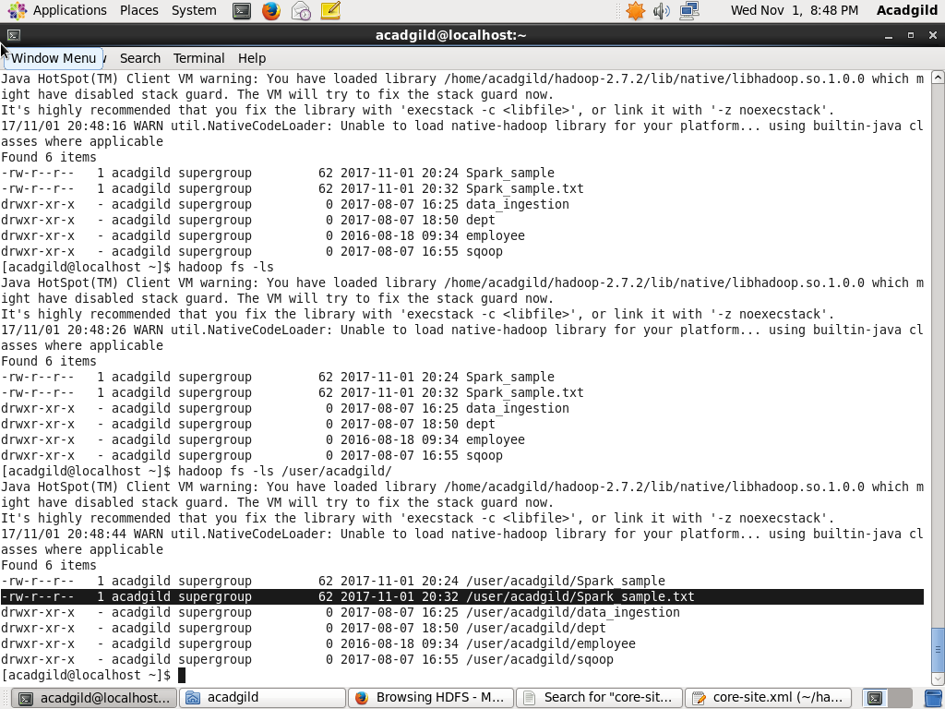

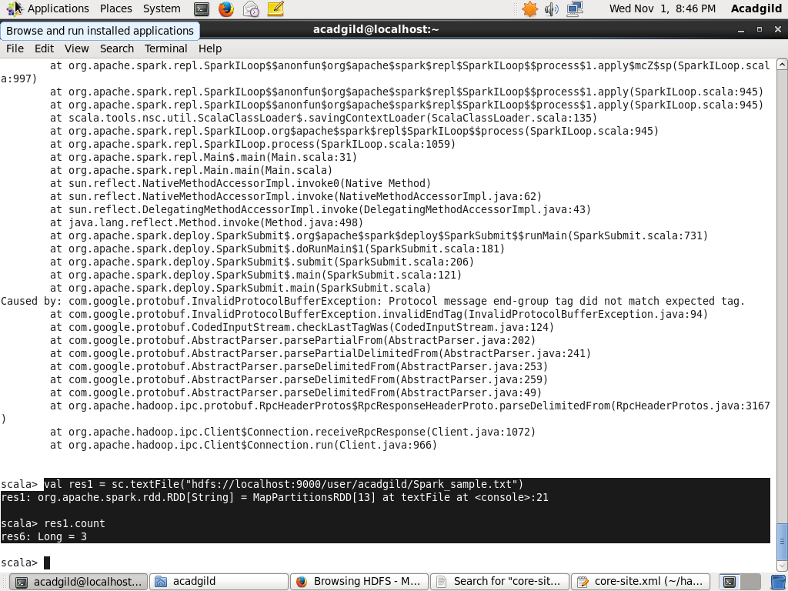

1. Write a program to read a text file and print the number of words in the document.

Sol:

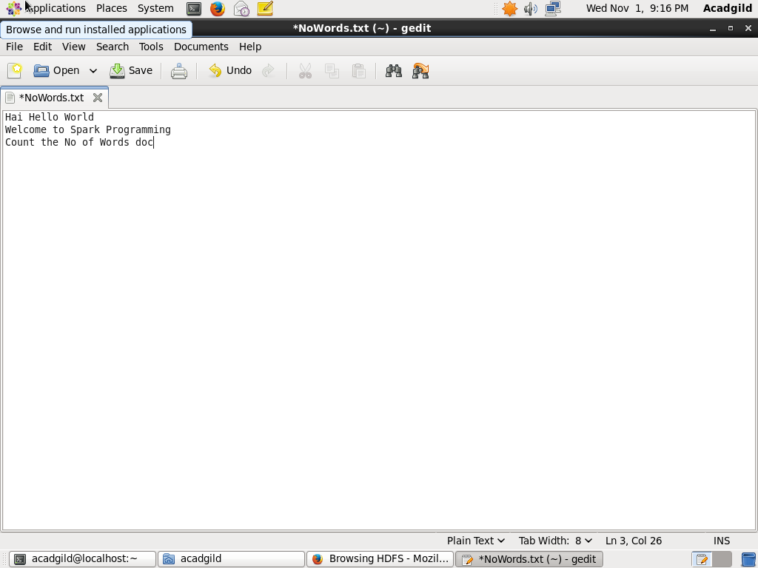

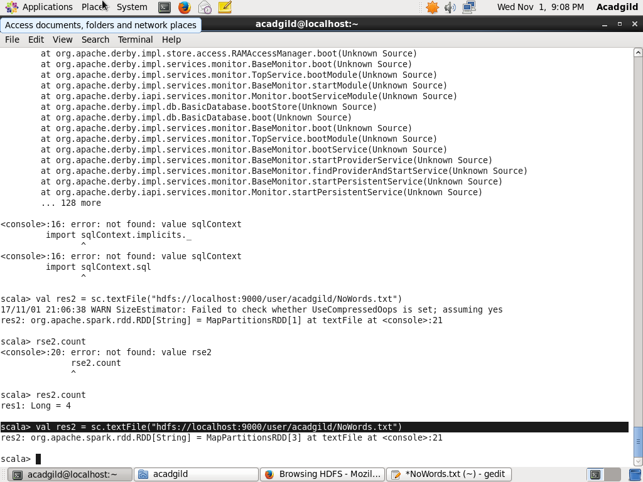

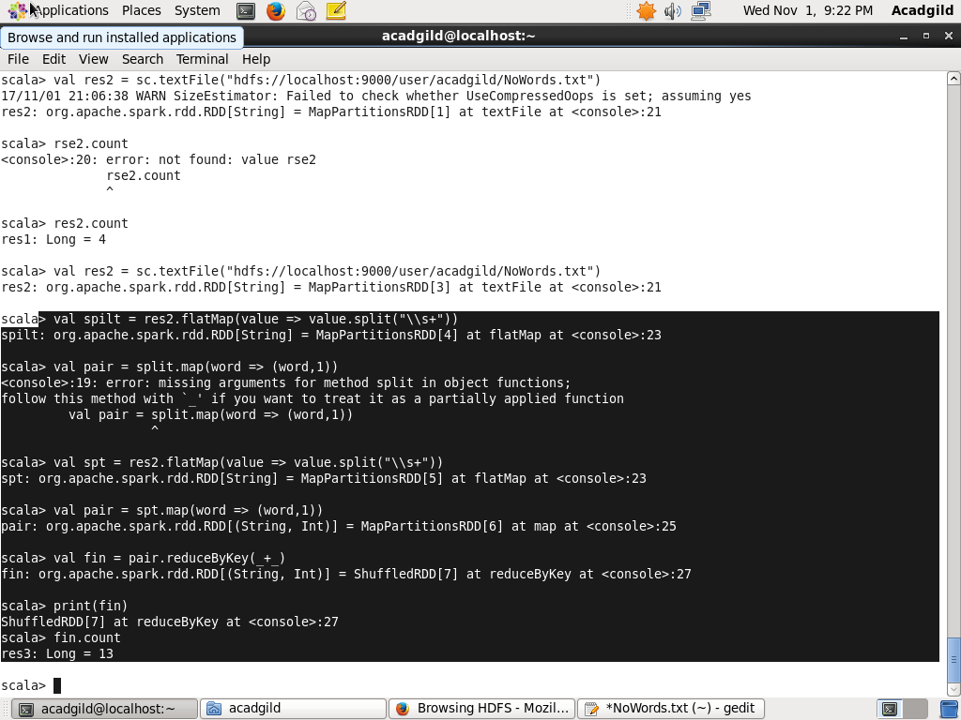

3. We have a document where the word separator is -, instead of space. Write a spark

code, to obtain the count of the total number of words present in the document.

Sol:



